**CS F212 – Database Systems**

**Automobile Dealership Management system**

|  |  |
| --- | --- |
| TEAM MEMBERS ID | NAMES |
| 1. 2022A7PS0201H (Leader) | Daksh Jain |
| 2. 2022A7PS1382H | Rushi Patel |
| 3. 2022A7PS1333H | Khush Bhuta |
| 4. 2022A7PS1334H | Utkarsh Singhal |
| 5. 2022A7PS1312H | Lakshya Maheshwari |

**GROUP ID* - G50**

# 1. INTRODUCTION/DESCRIPTION

In this section, we describe a sample database application, called Deals_On_Wheels DB, which serves to illustrate the basic ER model concepts and their use in schema design. We list the data requirements for the database here, and then create its conceptual schema step-by-step as we introduce the modelling concepts of the ER model. The Deals_On_Wheels DB database keeps track of a car dealership’s customers, employees, suppliers, sales, and vehicles. Suppose that after the requirements collection and analysis phase, the database designers provide the following description of the miniworld – the part of the dealership that will be mentioned in the database:

* Suppliers provide vehicles, each identified uniquely by a Supplier ID.
* Employees work at the dealership and handle sales transactions. Each employee has a unique Employee ID.
* Dependents are family members whose name, address, relationship, etc are stored separately for each employee.
* Customers visit the dealership to purchase vehicles. Each customer is identified uniquely by a Customer ID.
* Sales transactions are recorded containing details such as the Sale ID, vehicle sold, customer making the purchase, employee handling the sale, sale date, price.
* Vehicle entity type stores information about all vehicle models, including names, prices, types, colours, brands, year, and their respective suppliers with each vehicle uniquely identified by its Vehicle ID.

Business rules:

* Each supplier can supply multiple vehicles, but each vehicle can only have one supplier.
* Each employee can make with multiple sales, but each sale is handled by one employee.
* Each customer can make multiple purchases but each sale is made to only one customer.
* Each employee can sell to multiple different customers, and each customer can have multiple sales from multiple different employees.
* Each sale involves one vehicle, one customer, and one employee.
* Each vehicle can be sold in one sale and each sale can sell only one vehicle.
* There can be multiple entries for a vehicle model in the Vehicle table differentiated by brand, colour, year.
* Each primary key uniquely identifies a record within its respective table and cannot be absent: Supplier_ID in Supplier Table, Employee_ID in Employee Table, Customer_ID in Customer Table, Sale_ID in Sales Table, Vehicle_ID in Vehicle Table
* Name is a partial key in the Dependent Table and identifies a dependent uniquely, so it cannot be absent.
* Foreign key constraints ensure referential integrity between related tables and create a consolidated web: Vehicle_ID in Sales table references Vehicle_ID in Vehicle Table, Customer_ID in Sales table references Customer_ID in Customer table, Employee_ID in Sales table references Employee_ID in Employee table, Supplier_ID in Vehicle table references Supplier_ID in Supplier Table, and Emploee_ID is the identifier for Name in Dependent table.
* Mgr_ID in employee table indicates the Employee_ID of the manager who is also an employee, thus creating a self-referencing relationship.

# 2. ER Model

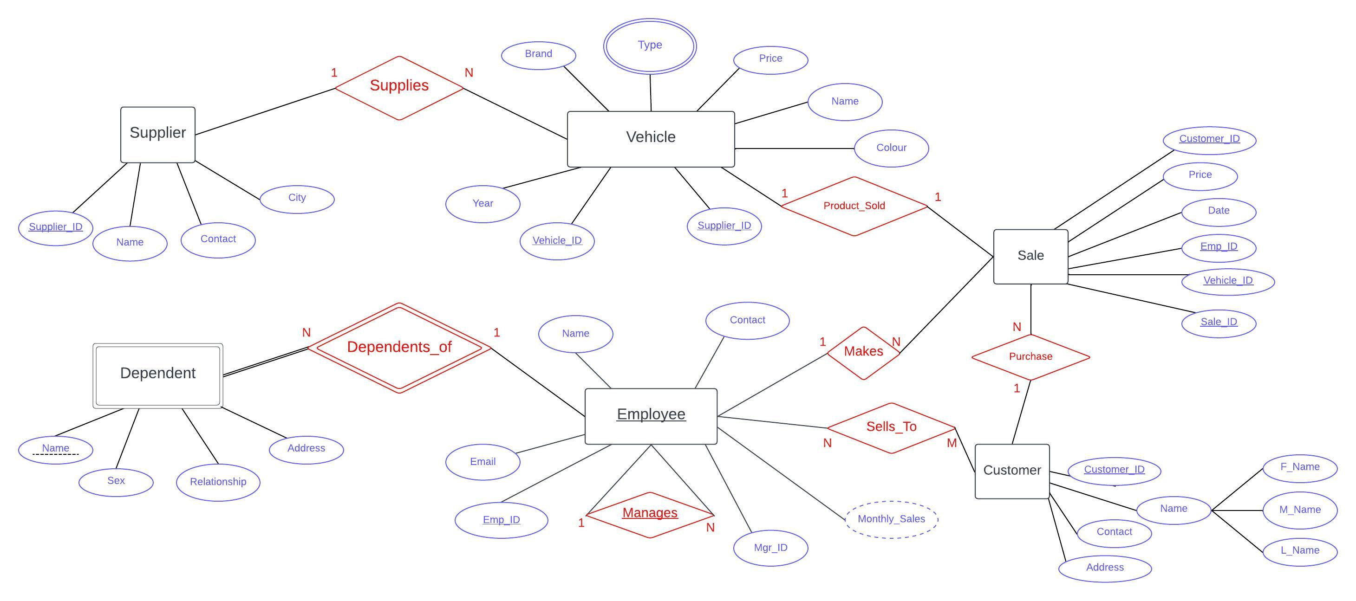

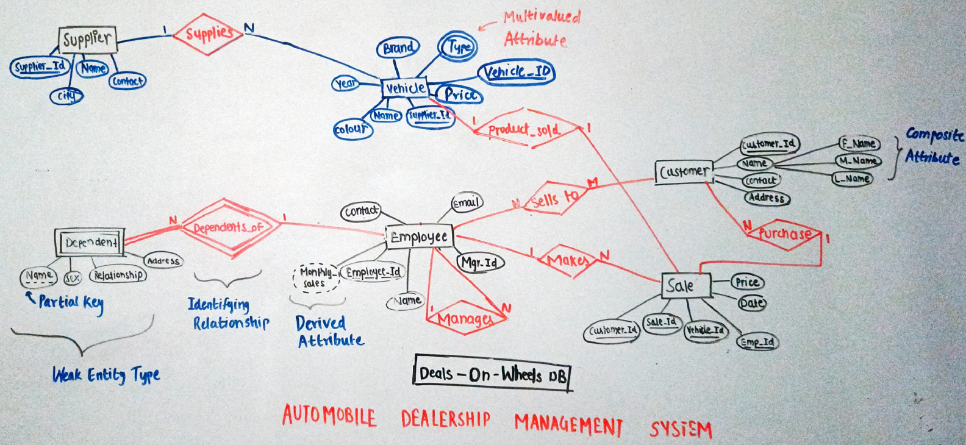

(ER Model Protoype)

* SUPPLIES - 1:N relationship between the Supplier and Vehicle Entity types.
* PRODUCT_SOLD - 1:1 relationship between the Vehicle and Sales Entity types.
* SELLS_TO - N:M relationship between Employee and Customer Entity types.
* PURCHASE - 1:N relationship between Sale and Customer Entity types.
* MAKES - 1:N relationship between Employee and Sales Entity types.
* MANAGES - 1:N self-relationship between the Employee Entity types.
* DEPENDENTS_OF - 1:N Identifying relationship between Employee and Dependent (Weak Entity Type).

**3. RELATIONAL MAPPING**

